Ethan Allen Luxury Royal Bed

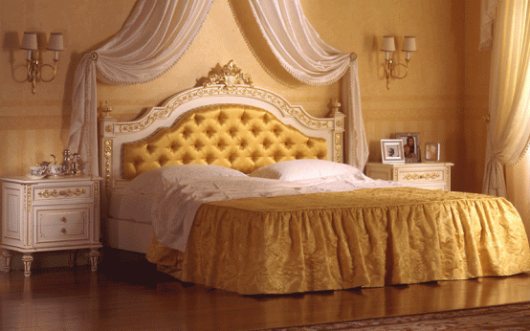

|  |
| --- |
| **DESCRIPTION** |
| ETHAN ALLEN introduces a luxury bed with high detailed design. This set of bed is sure to create the perfect look in any home. The rich wood with double mattress gives extra comfort. Perfect for any room of the house, your guests will love this comfortable mood lifting bed and the feeling of refreshment will make you worth sleeping for. |

|  |  |  |
| --- | --- | --- |
| **Price** | **2000$** | |
| **Dimensions** | **H** x **W** x **L** | **25in x 55in x 77in** |
| **Features** | **Dual mattress increases your comfort level and relaxes you spinal cord making you back upright so that you do not feel drowsy when you walk.** | |
| **Finished** | **Smooth stretchable cloth** | |
| **Available in** | **White Only** | |